QMC access

RDP to Development/ Production Environment
Add user to Administrator Group:

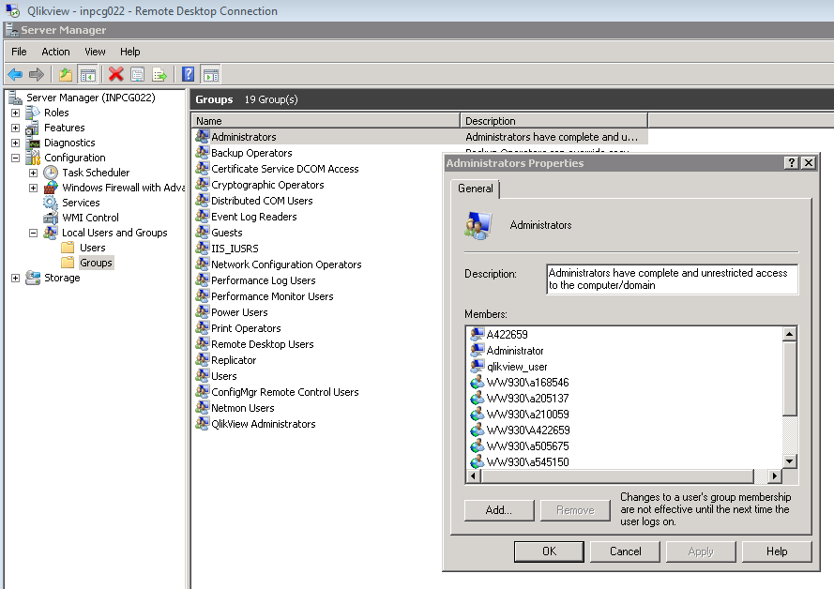

Granting Access to user:

Check role granted on a dashboard,
- go to QMC,
- edit task

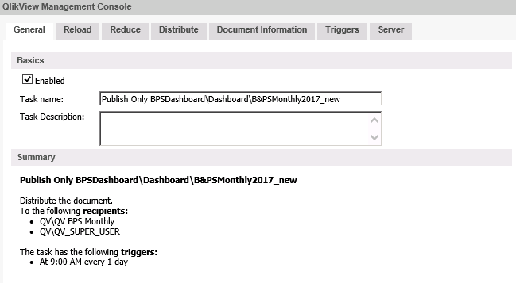

Add user on said role in ITAP role management. After granting access to the user, if required, reload the dashboard. Ask user to re-login on ITAP portal.

Document CALs
Currently 60 Doc CALs have been assigned to B&PS Monthly dashboard and 150 Doc CALs to B&PS Weekly Dashboard. The same can be changed based on requirement from business. Follow below process to change the allocation of document CALs from respective dashboards.
- In QMC go to “Documents” tab and click on “User Document” sub-tab.
- Select dashboard and click on “Document CALs” tab appears on right side of the window.
- Change “Number of CALs allocated to this document” to the number of CALs to be reserved for said dashboard.
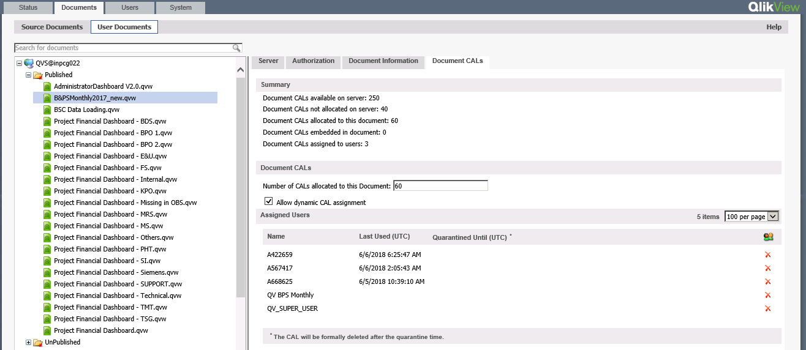

User CALs
As per license agreement, we have 30 user CAL licenses available with us. these licenses are used by development and administration team for development and management of dashboards.
Follow below steps for assignment of user CALs to developers:

In QMC, Select System tab and click on “Licenses”. On right side of the screen, Click on “Assigned CALs”. There you will find all users with assigned User CALs. Click on icon for adding or deleting users.

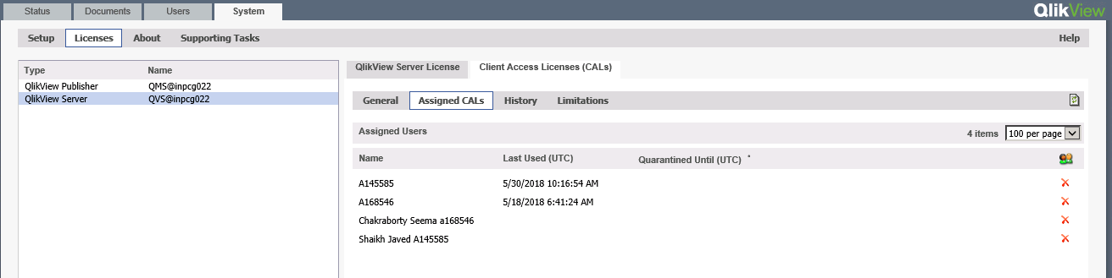
Connecting to LDAP server:
Access to Qlikview dashboard is after DAS authentication. Configuration of LDAP server need to be done in qlikview under System Setup.
- In QMC, click on System Tab, expand “Directory Service Connectors (DSC)”.
- Click on “Active Directory”
- on Right side window, set Path to “LDAP://ww930.my-it-solutions.net”
- User functional user “ww930/w99saf10” as user name
- Enter password for the user and click on “Apply”.
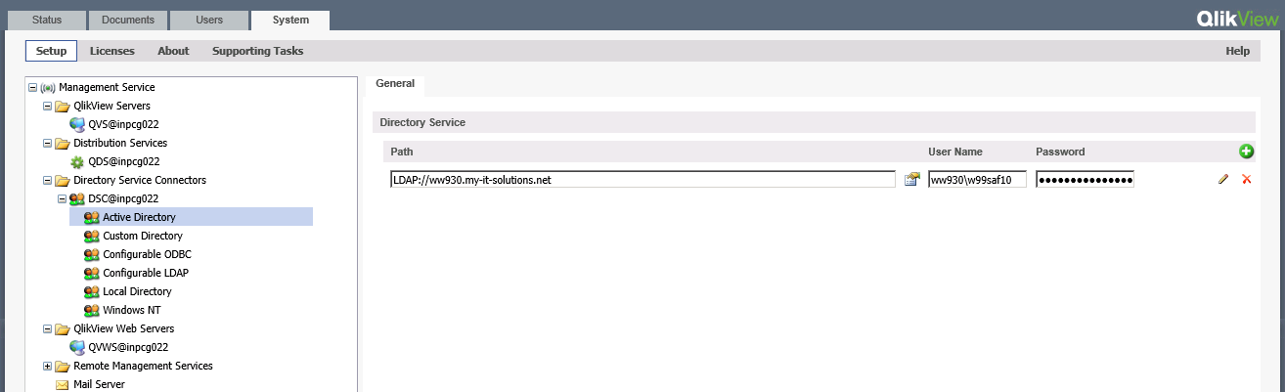

Configuring ODBC:
Role management is configured thru ITAP role management module. To access the roles from ITAP database, ODBC needs to be configured to retrieve list of roles granted to the user.
In QMC, click on System Tab, expand “Directory Service Connectors (DSC)”.
- Click on “Configuratble ODBC”
- on Right side window, set Path to “ODBC://localhost”
- User db user “beti_prod” as user name
- Enter password for the user and click on pencil icon next to password input box.
- Configure DSP settings as follows:
Service timeout in seconds | 30
Directory label | QV
Entity name | name
Entity table db name | VW_QV_Entity
Groups table db name | VW_QV_GroupMap
Data source name
Conn db name
Override connection string | Driver={SQL Server Native Client 10.0};Server=172.16.33.33;Database=MasterBETI;Uid=beti_prod;Pwd=beti_2011;
Cache expiry in minutes | 15

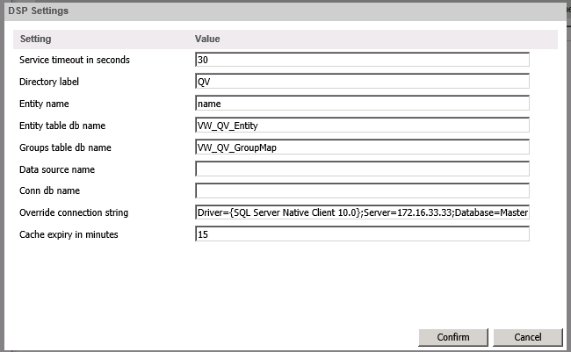

Qlikview License

Qlikview Server
Serial No.: 9109460366341219
Control:57608

Contents of LEF file:
9109460366341219
PRODUCTLEVEL;10;;2014-07-01
NUMBER_OF_USERCALS;30;;
NAMED_CAL_BY_MACHINE_ID;NO;;
NUMBER_OF_DOCUMENTCALS;250;;
DF7Y-H43T-XCM7-QR3H-K5CP

Qlikview Publisher

Serial No:9100460327921843
Control:10715

Contents of LEF file:

9100460327921843
PRODUCTLEVEL;30;;2014-07-01
GRTU-8NEU-EPNA-C5GG-QMHJ

